SIMATS ENGINEERING
ASSESSMENT TOOL 3
COURSE NAME: INTERNET PROGRAMMING
COURSE CODE: CSA43

COURSE OUTCOME COVERED
CO-1: Develop well-structured, standards-compliant web pages using HTML/XHTML and XML, and apply Internet protocols and HTTP communication mechanisms for web content delivery. (L2)
Assessment Tool: Code along exercise: Make your first HTML page together with CSS
Weightage: 10%
QUESTIONS: Total Marks: 10

Scenario: Web Development Standards Implementation
A start up is developing a modern web application. During development, the team encounters multiple issues related to HTML elements, HTTP methods, XML syntax, and web communication protocols.
The following observations are made:
- The team needs to embed a promotional video on the homepage.
- A registration form must securely send user data to the server.
- The navigation menu must follow semantic HTML standards.
- XML configuration files are being used but contain syntax errors.
- The application must communicate over the correct web protocol.

Data Snippets Provided

Snippet 1: Video Embedding Options
A. <media src="video.mp4"></media>
B. <video src="video.mp4" controls></video>
C. <movie src="video.mp4"></movie>
D. <vid src="video.mp4"></vid>

Snippet 2: Form Submission Methods
A. GET
B. POST
C. PUT
D. DELETE

Snippet 3: Navigation Elements
A. <div>
B. <nav>
C. <section>
D. <header>

Snippet 4: XML Syntax
A. <note><to>User</to><from>Admin</from>
B. <note><to>User</to><from>Admin</from></note>
C. <note><to>User</from></note>
D. <note to="User"></note

Snippet 5: Web Communication Protocols
A. FTP
B. HTTP
C. SMTP
D. SNMP

Answers and Justifications

1. Select the correct HTML tag for video embedding and justify your answer.
Correct answer: B. <video src="video.mp4" controls></video>
Justification: The HTML5 <video> element is designed to embed video content in a web page. The src attribute specifies the video file, and the controls attribute displays built-in playback controls such as play, pause, and volume. The other options use non-standard HTML element names.

2. Identify the appropriate HTTP method for form submission and explain why.
Correct answer: B. POST
Justification: POST sends form data in the request body and is commonly used to submit registration details that create or process information on the server. GET places submitted values in the URL and is not suitable for sensitive registration data. POST alone does not encrypt data; HTTPS should be used to protect data in transit, and the server must validate the submitted information.

3. Choose the proper semantic element for navigation and justify its usage.
Correct answer: B. <nav>
Justification: The <nav> element semantically identifies a section containing major navigation links. It improves document structure and supports accessibility tools. A <div> is generic, <section> is for a thematic section, and <header> represents introductory content or a group of navigational aids rather than specifically identifying the navigation region.

4. Identify the correct XML syntax and explain the error in other options.
Correct answer: B. <note><to>User</to><from>Admin</from></note>
Justification: XML requires elements to be properly nested and every opened element to have a matching closing tag. Option A does not close the outer <note> element. Option C mismatches the <to> opening tag with a </from> closing tag. Option D is missing the closing angle bracket in the final </note> tag.

5. Choose the correct protocol for web communication and justify your choice.
Correct answer: B. HTTP
Justification: HTTP (Hypertext Transfer Protocol) is used for communication between web clients, such as browsers, and web servers to request and deliver web resources. HTTPS is the secure version of HTTP and should be used for modern applications that transmit registration data. FTP is for file transfer, SMTP is for sending email, and SNMP is used for network management.
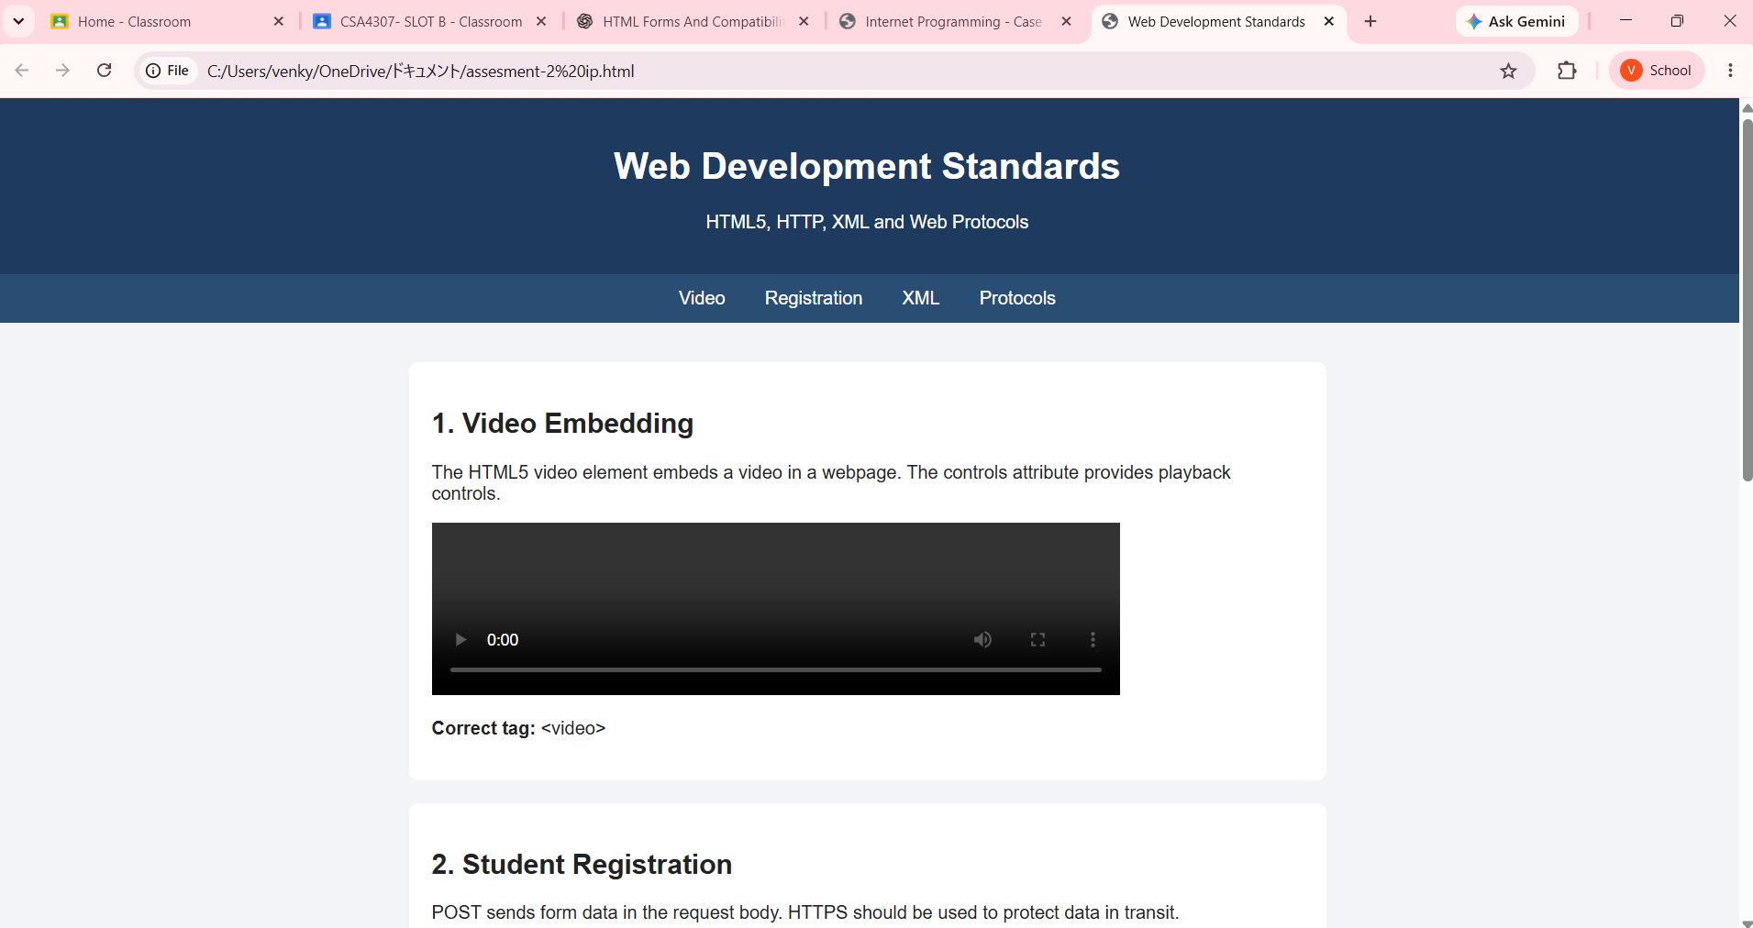
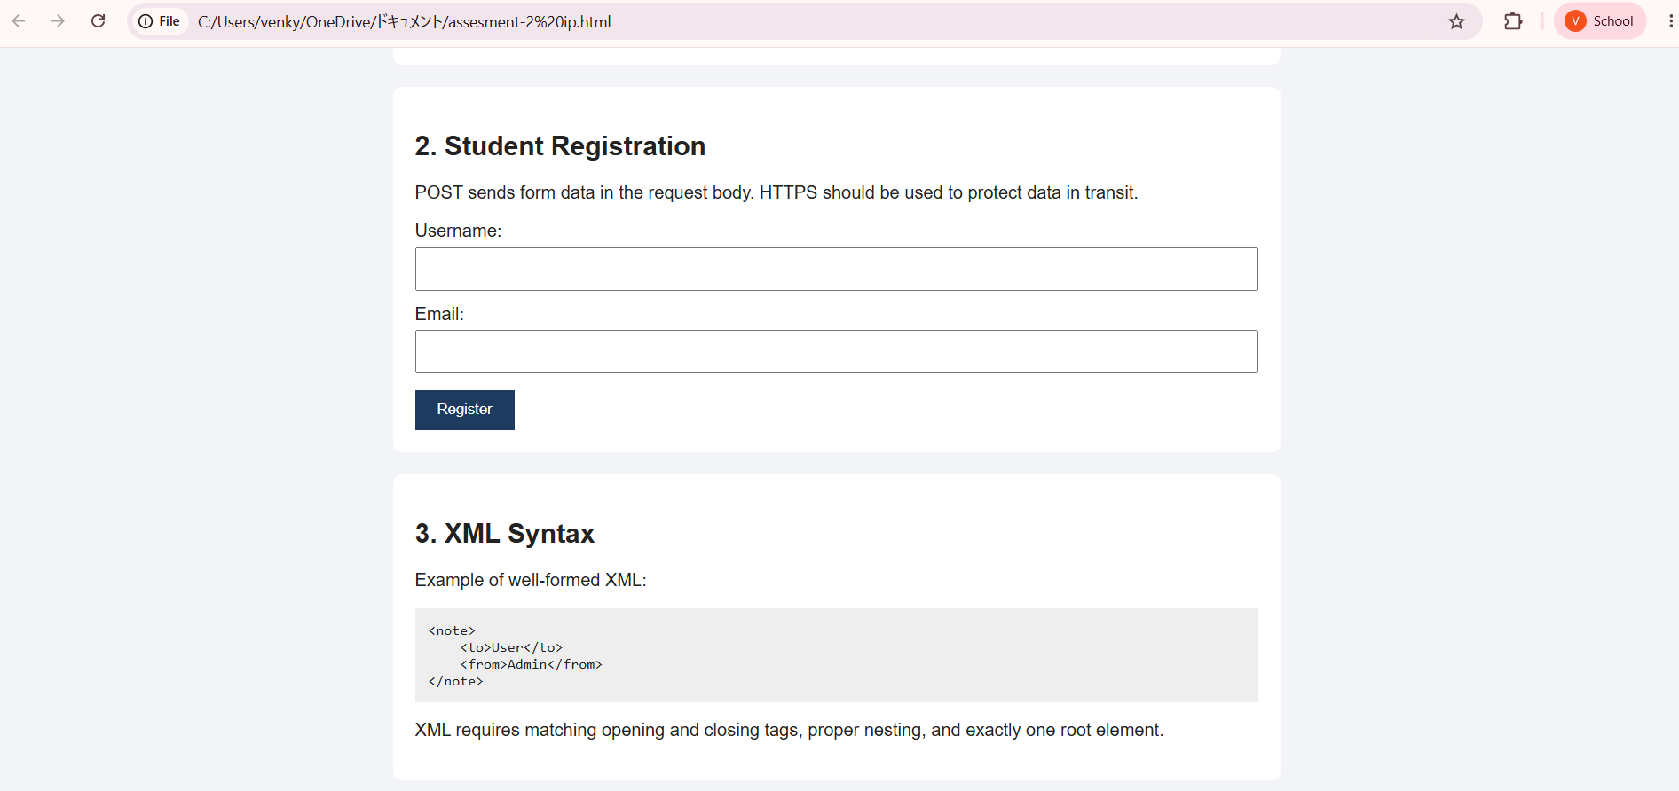
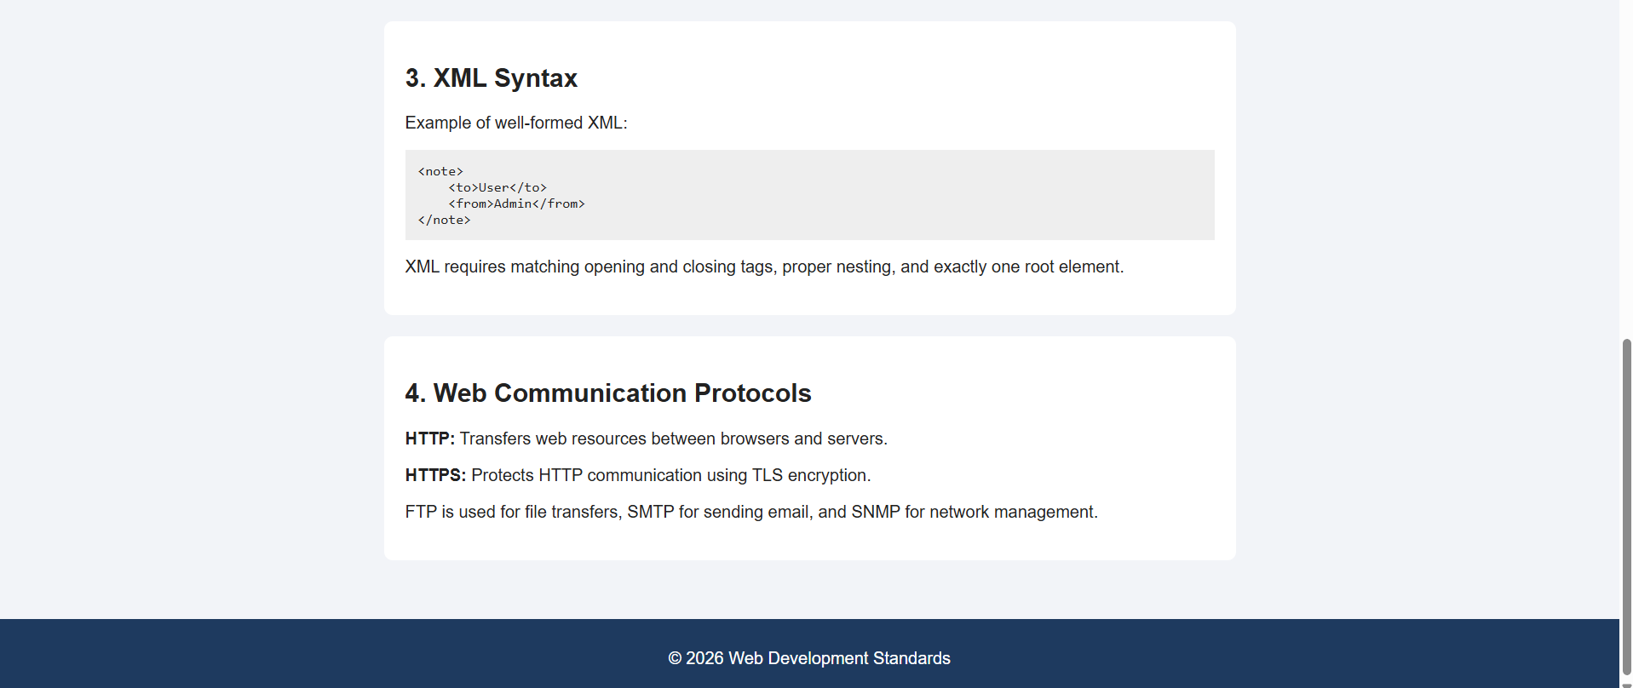

Code of Conduct
I Venkateswarlu(192411239) (Name / Reg No) certify that this submission is my original work and that I have adhered to the guidelines specified for this assessment. I understand that any violation of academic integrity rules will result in disciplinary action.
Signature of the student: 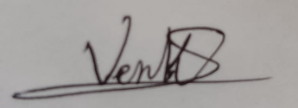

RUBRICS FOR CALCULATION
Criteria | Weightage | Level 4 – Exemplary | Level 3 – Proficient | Level 2 – Developing / Level 1 – Beginning
Understanding of Case | 25 | Thorough understanding; clearly identifies all key issues. | Good understanding with most issues identified. | Level 2: Basic understanding; some issues missed. Level 1: Poor understanding; problem not identified correctly.
Application of Concepts | 25 | Effectively applies relevant concepts to analyze the case deeply. | Applies appropriate concepts with minor gaps. | Level 2: Limited application of concepts. Level 1: Fails to apply relevant concepts.
Analysis | 20 | In-depth analysis with strong reasoning and insights. | Good analysis with logical reasoning. | Level 2: Basic analysis with limited depth. Level 1: Weak or no analysis; lacks reasoning.
Solution Design | 20 | Innovative, feasible solutions with strong justification. | Logical solutions with adequate justification. | Level 2: Basic solutions with weak justification. Level 1: Incorrect or no solution provided.
Clarity | 10 | Clear, well-structured, and easy to understand presentation. | Organized and understandable presentation. | Level 2: Limited clarity and structure. Level 1: Poor clarity; difficult to understand.

